The Logical Model

A logical model is a static view of the objects and classes that make up the design/analysis space. Typically, a Domain Model is a looser, high-level view of Business Objects and entities, while the Class Model is a more rigorous and design focused model.

The Class Model
A Class is a standard UML construct used to detail the pattern from which objects will be produced at run-time. A class is a specification - an object an instance of a class. Classes may be inherited from other classes (that is they inherit all the behavior and state of their parent and add new functionality of their own), have other classes as attributes, delegate responsibilities to other classes and implement abstract interfaces.

A class encapsulates state (attributes) and offers services to manipulate that state (behavior). Good object-oriented design limits direct access to class attributes and offers services, which manipulate attributes on behalf of the caller. This hiding of data and exposing of services ensures data updates are only done in one place and according to specific rules - for large systems the maintenance burden of code which has direct access to data elements in many places is extremely high.
The class is represented as below:
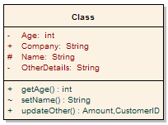
Note that the class has three distinct areas:
The class name (and stereotype if applied)
The class attributes area (that is internal data elements)
The behavior - both private and public

Attributes and methods may be marked as
Private, indicating they are not visible to callers outside the class
Protected, they are only visible to children of the class
Public, they are visible to all

Class inheritance is shown as below: an abstract class in this case, is the parent of two children, each of which inherits the base class features and extends it with their own behavior.
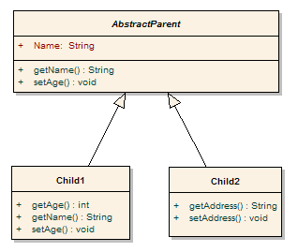 Class models may be collected into packages of related behavior and state. The diagram below illustrates this.
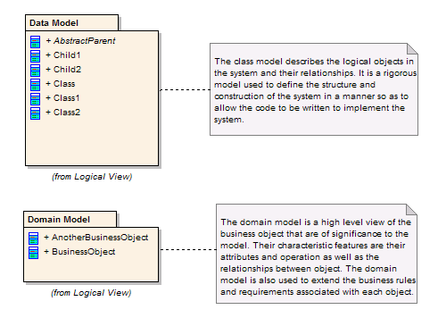
Class diagrams
A Class diagram gives an overview of a system by showing its classes and the relationships among them. Class diagrams are static -- they display what interacts but not what happens when they do interact.
The class diagrams below models a customer order from a retail catalog. The central class is the Order. Associated with it is the Customer making the purchase and the Payment. A Payment is one of three kinds: Cash, Check, or Credit. The order contains OrderDetails (line items), each with its associated Item.
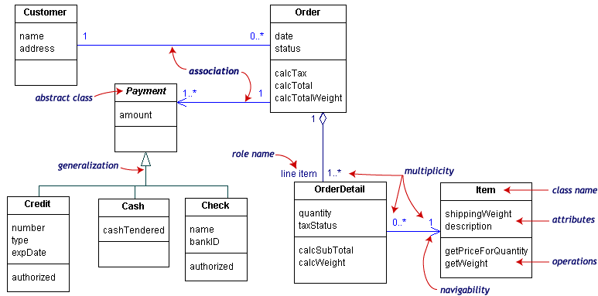
UML class notation is a rectangle divided into three parts: class name, attributes, and operations. Names of abstract classes, such as Payment, are in italics. Relationships between classes are the connecting links.
Our class diagram has three kinds of relationships.
Association -- a relationship between instances of the two classes. There is an association between two classes if an instance of one class must know about the other in order to perform its work. In a diagram, an association is a link connecting two classes.
Aggregation -- an association in which one class belongs to a collection. An aggregation has a diamond end pointing to the part containing the whole. In our diagram, Order has a collection of OrderDetails.
Generalization -- an inheritance link indicating one class is a super class of the other. A generalization has a triangle pointing to the superclass. Payment is a superclass of Cash, Check, and Credit.
An association has two ends. An end may have a role name to clarify the nature of the association. For example, an OrderDetail is a line item of each Order.
A navigability arrow on an association shows which direction the association can be traversed or queried. An OrderDetail can be queried about its Item, but not the other way around. The arrow also lets you know who "owns" the association's implementation; in this case, OrderDetail has an Item. Associations with no navigability arrows are bi-directional.
The multiplicity of an association end is the number of possible instances of the class associated with a single instance of the other end. Multiplicities are single numbers or ranges of numbers. In our example, there can be only one Customer for each Order, but a Customer can have any number of Orders.
This table gives the most common multiplicities.
Multiplicities | Meaning
0..1 | zero or one instance. The notation n. m indicates n to m instances.
0..* or * | No limit on the number of instances (including none).
1 | Exactly one instance
1..* | At least one instance
Every class diagram has classes, associations, and multiplicities. Navigability and roles are optional items placed in a diagram to provide clarity.
Digging Deeper: Class Diagrams

Composition and Aggregation
Associations in which an object is part of a whole are aggregations. Composition is a strong association in which the part can belong to only one whole -- the part cannot exist without the whole. Composition is denoted by a filled diamond at the whole end.
This diagram shows that a BoxOffice belongs to exactly one MovieTheater. Destroy the MovieTheater and the BoxOffice goes away! The collection of Movies is not so closely bound to the MovieTheater.
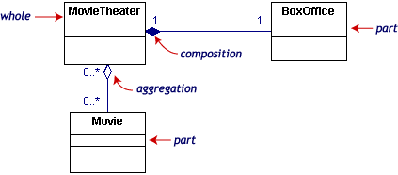
Class information: visibility and scope
The class notation is a 3-piece rectangle with the class name, attributes, and operations. Attributes and operations can be labeled according to access and scope. Here is a new, expanded Order class.
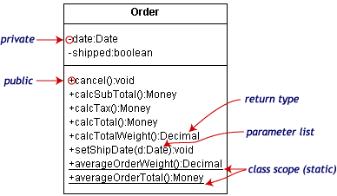
The illustration uses the following UML™ conventions.
- Static members are underlined. Instance members are not.
- The operations follow this form:
<access specifier> <name> ( <parameter list>) : <return type>
- The parameter list shows each parameter type preceded by a colon.
- Access specifiers appear in front of each member.
Symbol | Access
+ | public
- | private
# | protected
Dependencies and constraints
A dependency is a relation between two classes in which a change in one may force changes in the other. Dependencies are drawn as dotted lines. In the class diagram below, Co_op depends on Company. If you decide to modify Company, you may have to change Co_op too.

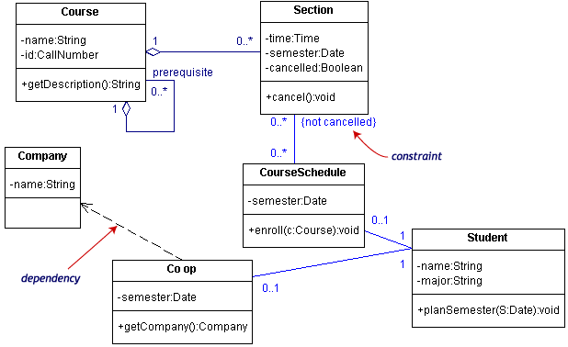

A constraint is a condition that every implementation of the design must satisfy. Constraints are written in curly braces { }. The constraint on our diagram indicates that a Section can be part of a CourseSchedule only if it is not canceled.
Interfaces and stereotypes
An interface is a set of operation signatures. In C++, interfaces are implemented as abstract classes with only pure virtual members. in Java, they're implemented directly.
The class diagram below is a model of a professional conference. The classes of interest to the conference are SessionTalk, which is a single presentation, and Session, which is a one-day collection of related SessionTalks. The ShuttleSchedule with its list of ShuttleStops is important to the attendees staying at remote hotels. The diagram has one constraint, that the ShuttleStops are ordered.

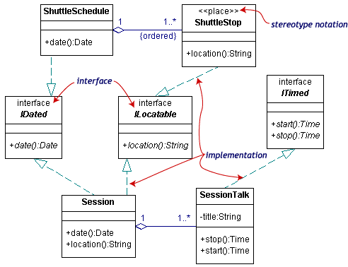
There are three interfaces in the diagram: IDated, ILocatable, and ITimed. The names of interfaces typically begin with the letter I. Interface names along with their (abstract) operations are written in italics.

A class such as ShuttleStop, with operations matching those in an interface, such as ILocatable, is an implementation (or realization) of the interface.
The ShuttleStop class node has the stereotype << place>>. Stereotypes, which provide a way of extending UML, are new kinds of model elements created from existing kinds. A stereotype name is written above the class name. Ordinary stereotype names are enclosed in guillemets, which look like pairs of angle-braces. An interface is a special kind of stereotype.
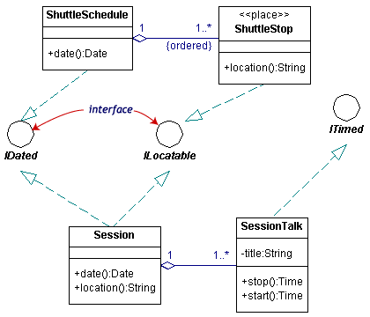
There are two acceptable notations for interfaces in the UML. The first is illustrated above. The second uses the lollipop or circle notation.

In circle notation, the interfaces are circles with lines connected to the implementing classes. Since it is more compact but leaves out some detail, the lollipop notation simplifies the original diagram.

Packages and object diagrams
To simplify complex class diagrams, you can group classes into packages. A package is a collection of logically related UML elements. The diagram below is a business model in which the classes are grouped into packages.

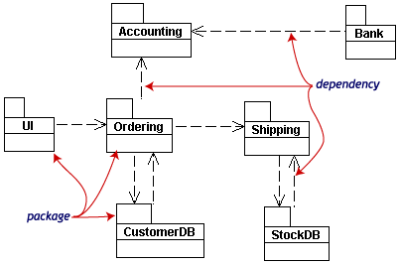
Packages appear as rectangles with small tabs at the top. The package name is on the tab or inside the rectangle. The dotted arrows are dependencies. One package depends on another if changes in the other could possibly force changes in the first.
Object diagrams show instances instead of classes. They are useful for explaining small pieces with complicated relationships, especially recursive relationships.
This small class diagram shows that a university Department can contain lots of other Departments.

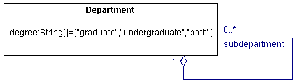
The object diagram below instantiates the class diagram, replacing it by a concrete example.
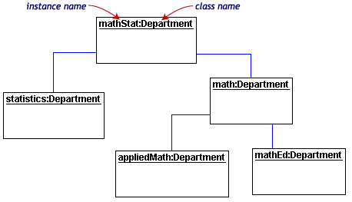

Each rectangle in the object diagram corresponds to a single instance. Instance names are underlined in UML diagrams. Class or instance names may be omitted from object diagrams as long as the diagram meaning is still clear.

